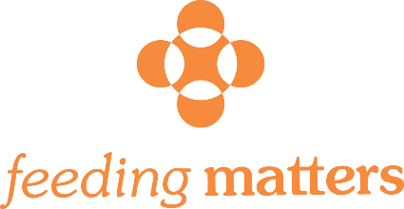

THIRD PARTY EVENT APPLICATION
Please submit your proposal at least 45 days prior to the scheduled event date.

Complete and return to Feeding Matters at events@feedingmatters.org.

General Information

Name of Company/Group: ____________________________________________________

Individual Contact Name: ___ __________________________________________________

Address:_____________________________ _____City:______________State:___________Zip:__________
Phone Number:____________________________ Email:__________________________________________
Event Description

Event Name:_______________________________ Event Date & Time:_______________________

Event Description (Please include ways in which funds will be raised)______________________
_________________________________________________________________________________________________________________________________________________________________________________________________________________________________________________________
Is event open to the public? Y N Will this be an annual event? Y N
Has this event been organized before? Y N Event Location:__________________________
What is the anticipated event revenue to be donated to Feeding Matters? ____________________

Would you like Feeding Matters brochures? Y N If yes, how many? ____________________________
Companies, foundations, community members you plan to approach for support: ____________________ ___________________________________________________________________________________________
___________________________________________________________________________________________
Requests of Feeding Matters staff: _____________________________________________________________
Additional Information: ______________________________________________________________________

